1. Write a program to find the sum of two numbers.   
   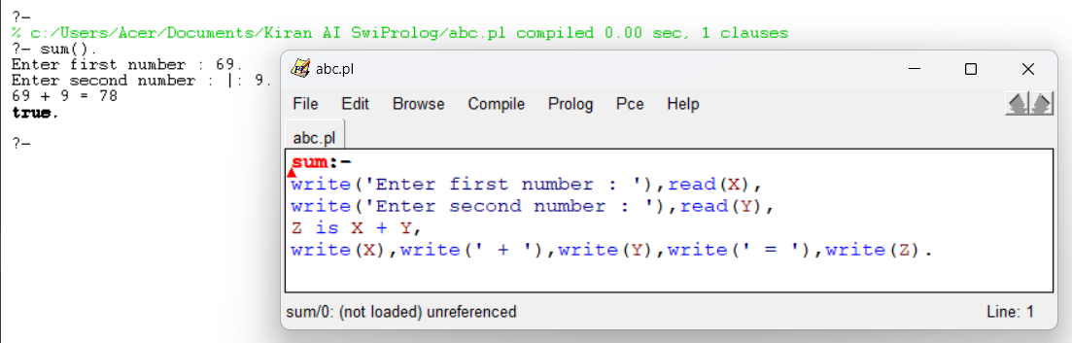
2. Write the program to find the family relation.  
   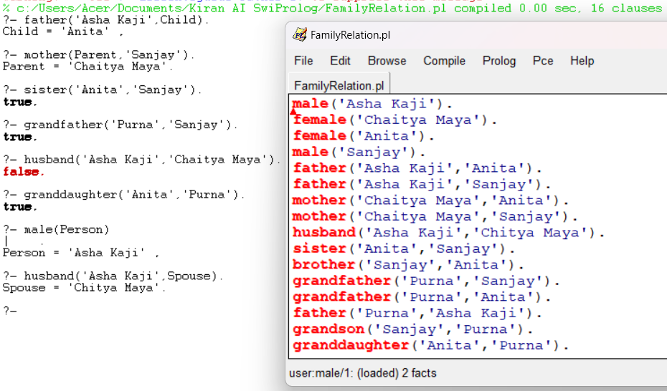
3. Write the program to find the medical diagnosis.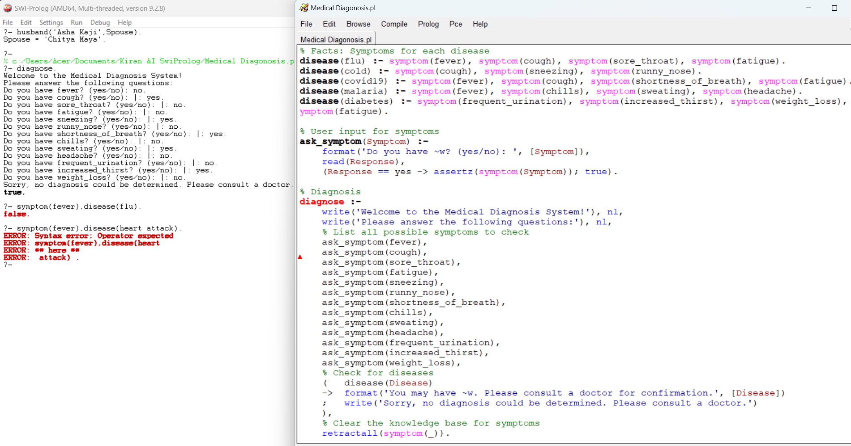
4. Write a program to find Area, Perimeter, Circle area and Circumference.  
   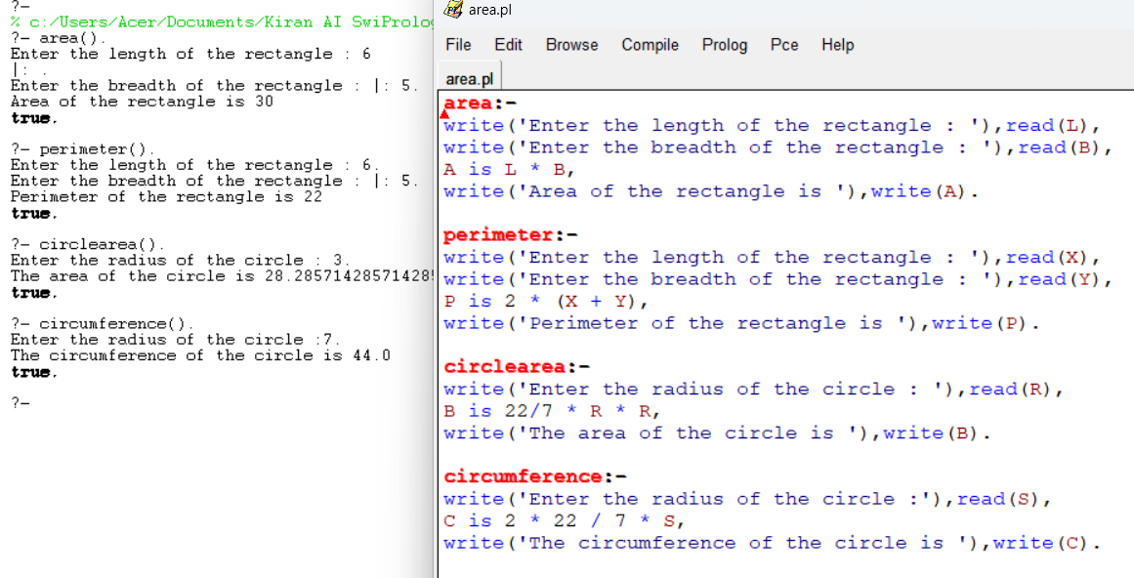
5. Arithmetic Operations using SWI Prolog  
   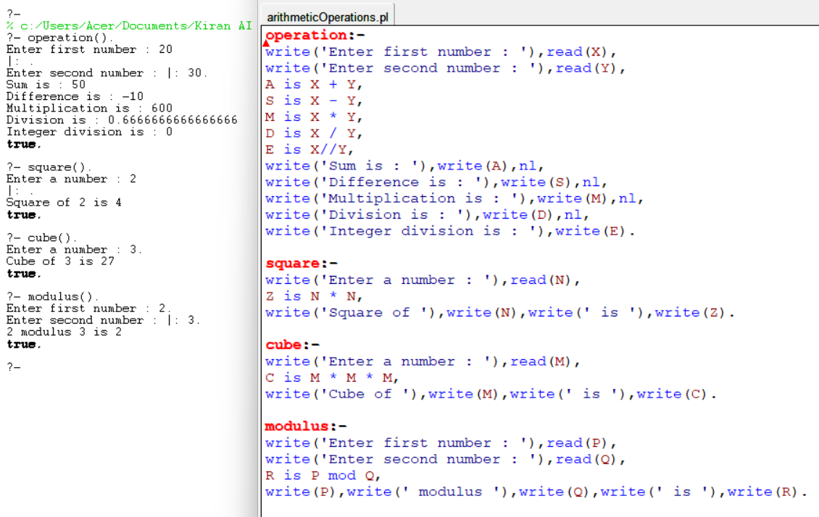
6. WAP to find the factorial of given Number.  
   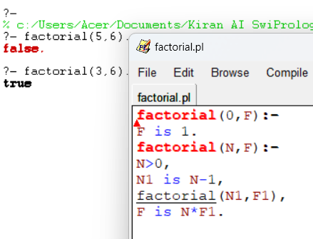
7. WAP to find the fibonacci equivalent number of given numbers  
   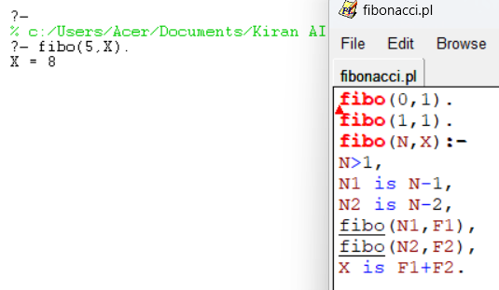
8. WAP to find GCD of two numbers.  
   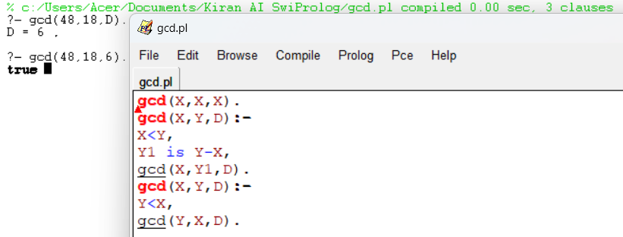
9. WAP to find the solution of tower of hanoi problem.  
   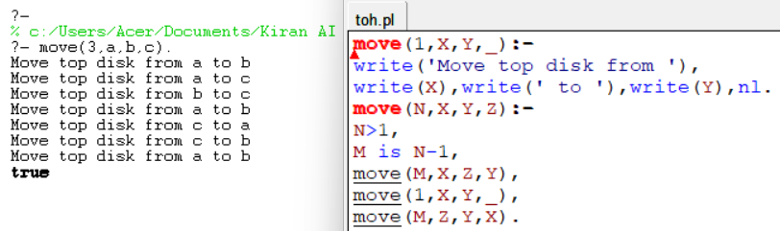
10. WAP to find the LCM of given number.  
    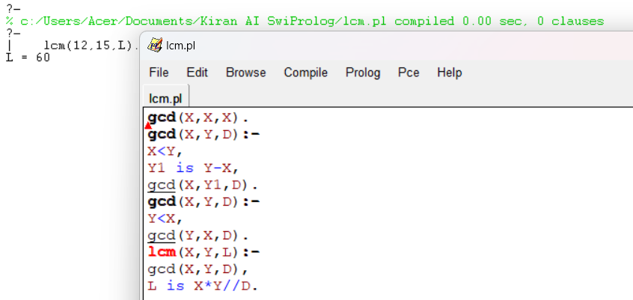
11. WAP to find cube of a number.  
    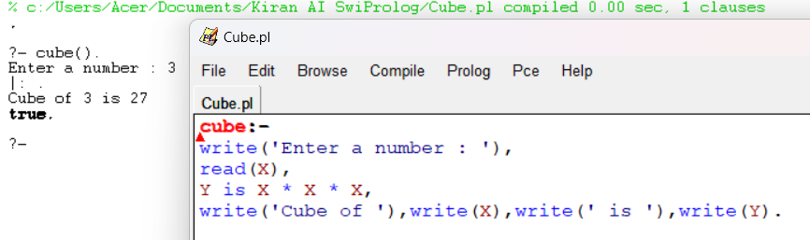
12. WAP to concatenate two lists.  
    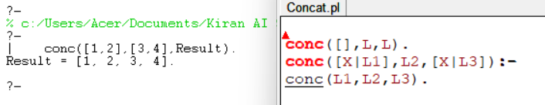
13. WAP to remove the first occurrence of an element X from a list.  
    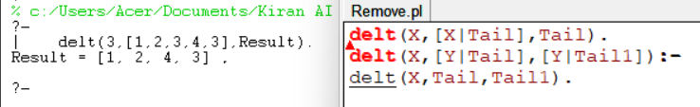
14. WAP to calculate the length of a given list.  
    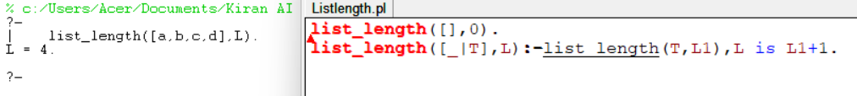
15. WAP to check if an element X is a member of a given list.  
    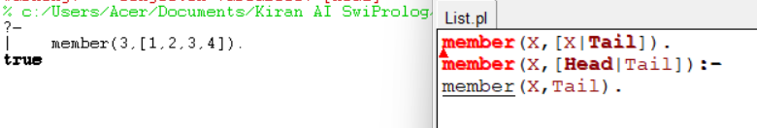
16. WAP to reverse a list.  
    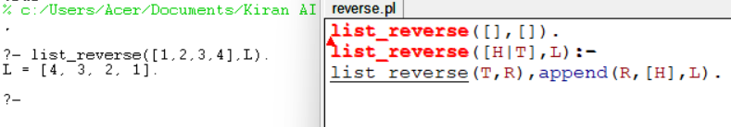
17. WAP to determine the greater of two numbers (X and Y) and binds it to Z.  
    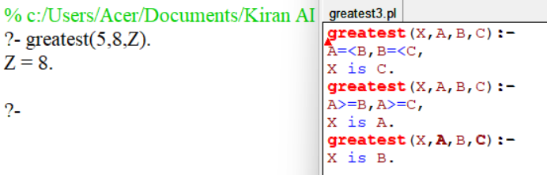
18. WAP to for concatenate lists, reverse a list, and check if a list is a palindrome.  
    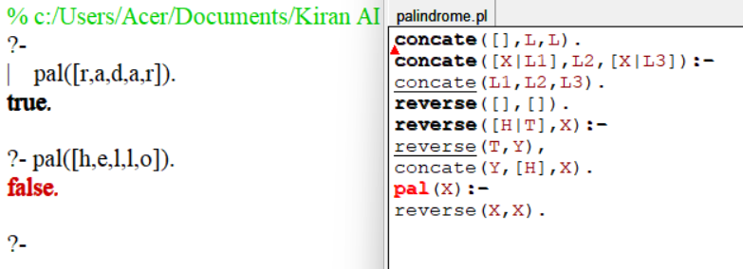
19. Write a Prolog program to generate all permutations of a given list.  
    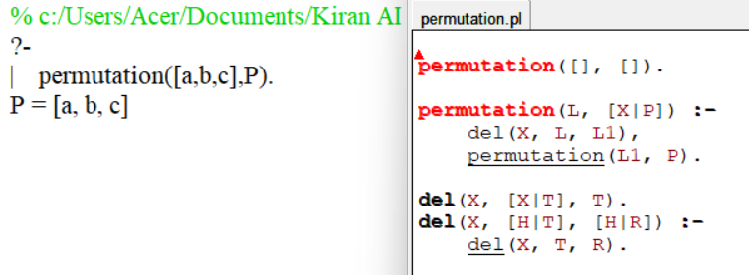
20. Write a Prolog program to calculate the average of a given list of numbers.  
    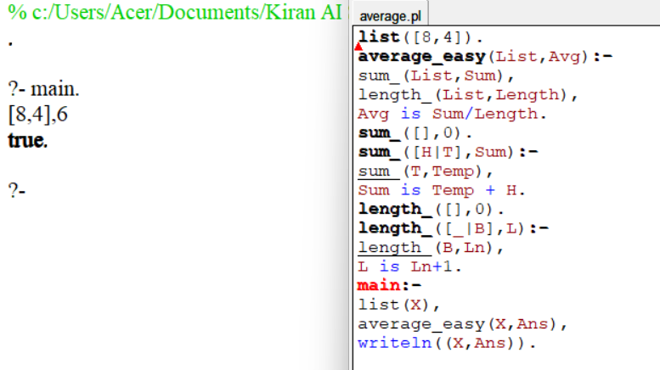
21. Write a Prolog program to compute all factors of a given number N.  
    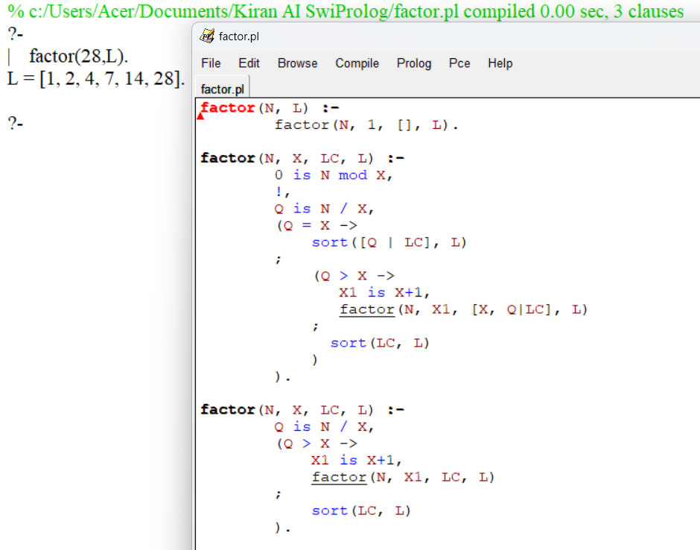
22. Write a program to find the relation. (Which locations are in Asia ?)  
    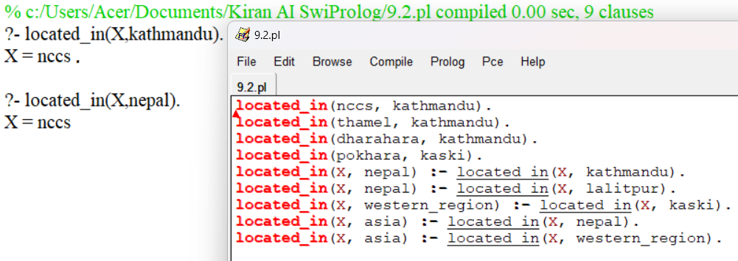
23. Write a program to find the greatest number among given number.  
    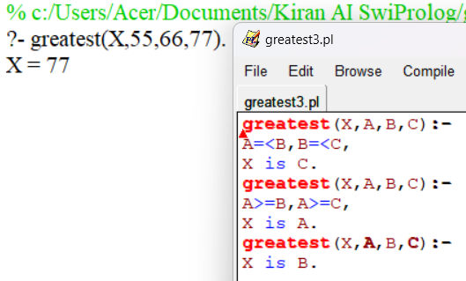
24. What are the values of S, M, E, N, D, O, R, and Y that satisfy the equation SEND + MORE = MONEY?  
    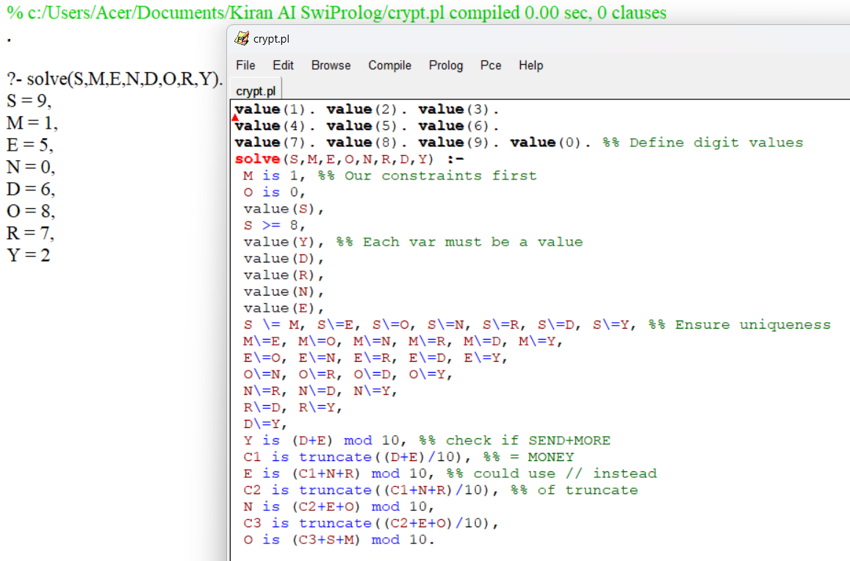
25. Write a program to print a square of stars with a side length X.  
    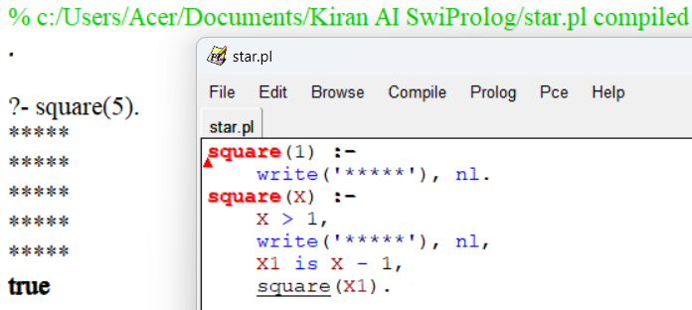
26. Write a program to find the path from the start node to the goal node using breadth-first search.  
    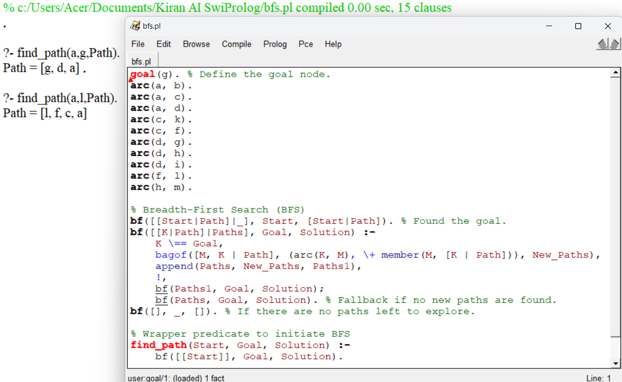
27. Write a program to find the path from the start node to the goal node using depth-first search.  
    